BLOCK CHAIN TECHNOLOGY
A seminar report submitted in partial fulfilment of the requirements
for the award of the degree of
BACHELOR OF TECHNOLOGY
IN
COMPUTER SCIENCE AND ENGINEERING
Submitted by
Chagarlamudi .Vivek
[17501A0516]

Department of Computer Science and Engineering
PRASAD V POTLURI SIDDHARTHA INSTITUTE OF TECHNOLOGY
(Affiliated to JNTU: Kakinada, Approved by AICTE)
(An ISO certified institution)
Kanuru, Vijayawada-520007
MARCH,2020.
MARKS AWARDED: /50

Signature of the Guide Signature of Head Of Department [C.S.E]

ABSTRACT

A Blockchain is basically a decentralized, dis-tributed ledger of all the transactions or events which takes place only after involving multiple parties. It ensures high level of security as the transactions which takes place are entirely anonymous. Each transactions or digital events taking place in a Blockchain network is verified, only if it is agreed upon by the consensus of the majority party of the users participating in this process. Blockchain is one of the emerging technologies in today’s world and a lot of revolution and research has just began regarding this distributed technology. Bitcoin has been the most popular cryptographic currency since it was invented and it is the best example that uses the Blockchain technology. In this paper, we will discuss about the research being done on this new domain of Computer Science.
We will outline the underlining concepts about this new technology. We will try to peek a bit into its applications in the financial and non financial sector. It is not only the most popular topic to discuss about, but is the most technological breakthrough, that is all set to revolutionize the entire world. With a blockchain, many people can write entries into a record of information, and a community of users can control how the record of information is amended and updated.No one person controls the information. Descending to ground level, however, the differences that make blockchain technology unique become more clear. While both run on distributed networks (the internet), Wikipedia is built into the World Wide Web (WWW) using a client-server network model. A user (client) with permissions associated with its account is able to change Wikipedia entries stored on a centralized server.
Whenever a user accesses the Wikipedia page, they will get the updated version of the ‘master copy’ of the Wikipedia entry. Control of the database remains with Wikipedia administrators allowing for access and permissions to be maintained by a central authority.

CONTENTS

TITLE PAGE NO.

- INTRODUCTION 06

- HISTORY AND EVOLUTION OF BLOCK CHAIN 07

- WORKING OF BLOCK CHAINS 15

- BLOCK CHAIN APPLICATIONS 17

- BLOCK CHAIN RESEARCH IN THE MODERN WORLD 19

- CONCLUSION 20

- REFERENCES 21

ACKNOWLEDGEMENT

I am extremely grateful to Dr.K.SHIVAJI BABU,principal,PRASAD.V .POTLURI SIDDHARTHA INSTITUTE OF TECHNOLOGY and Dr.A. JAYA LAKSHMI, Head Of Department, Computer Science Engineering for providing all the required information for the completion of the seminar. The satisfaction that accompanies the successful completion of task would be incomplete without mentioning the people who encouragement, guidance crown all the efforts with success. I reckon to a distant pleasure to endorse out deep sense of gratitude to DR.K.KOTESWARA RAO, Department of Computer Science and Engineering for his encouragement in all endeavours.

CHAGARLAMUDI.VIVEK
[17501A0516]

1.INTRODUCTION

Blockchain is a decentralized ledger or data structure. It can be referred as blocks in a chain where the corresponding blocks refer to the blocks, prior to them. Once the details of the transactions or events are fed into the Blockchain, it is impossible to tamper the details are shared with the members of the network.Users of the Blockchain network is completely aware of the transactions taking place. We will draw an analogy to justify the concept. We consider it to be a book based data structure where each page of the book refer to its previous page by a page. Here, book refers to the Blockchain, page refers to the book and an entry in any page refers to the blockchain transaction. It is easy to detect whether a page or a block has been tampered or not. Pages can be arranged in any manner so pages aren’t important in a distributed ledger. Now, In Blockchain, each block is built on top of the previous block and it uses the latter’s nonce and signature as a key for going into the next block. Miners of the network does the job of building a block and adding it to the chain. It is easy for the miners to guess a random string or nonce in order to tamper the block just by knowing the signature in a Public Blockchain. It is not easy to add blocks in the Blockchain and there is a reward of 12.5 bitcoins for that. In a Private Blockchain, the miners are given a contract and as a result, they can add on blocks to the chain. So, it can also be defined as a consensus oriented secured distributed public/private ledger which stored data over a peer to peer network.

- Advantages of Blockchain:

The BlockChain protocols has several features.
We have listed out few of them.

- Immutable: It means that it is really difficult to tamper or after a block.
- Irreversible: This feature prevents double spending.
- Distributed system: It means that a copy of the ledger is present with all its members.
- No Centralized Authority: It doesn’t depend on a central server to dominate and hence, a peer to peer system.
- Resilient: This feature shows that it is not prone to any sort of major attacks.

I.HISTORY AND EVOLUTION OF BLOCKCHAIN:

The history of the Blockchain can be showed by considering the example of one of its counterparts. We are talking about the BitCoin Blockchain. Satoshi Nakamoto invented Bitcoin and since then, it is the most popular and used Cryptocurrency. He developed the concept of Bitcoin as a currency, as resilient and trustworthy. But it had few anomalies.
1.One kind of asset: It was primarily built as a currency. It isn’t applicable for other modes or assets.
2.Time taking: Satoshi Nakamoto’s aim was to achieve the maximum possible consensus in order to pass a transaction. It doesn’t give attention to the time taken to validate the same.Hence, the process is getting slow. The developers of Blockchain are working on different kind of technologies. We have cited few examples here.

Colored Coins:
The protocols which allows the digital assets other than Bitcoin to be transferred in the Bitcoin Blockchain using the Bitcoins as “tokens”.
Bitcoins can be used as a transfer element for the Bitcoin transaction where it can be regarded a meta data for representation of shares, property and other instances

B.Alternative Blockchains:

This is also termed as “Sidechains”. In the Alternative Blockchain feature, we can shift the bitcoins of the Bitcoin Blockchain to a new Blockchain. We can transfer using Bitcoins having said that, we have to adapt to the new rules as well. We might have lesser time for Validation, more easily programmable and most importantly, a separate consensus mechanism. It ensures user scalability.

C. Ethereum Blockchain:

It is the newly developed Blockchain and it operates using digital contracts known as “Smart Contracts”. The protocol for Ethereum is different from Bitcoin Blockchain. Smart Contracts are basically small computer programs that accounts for a deal between a client and an end user. Blockchain has a wide range of financial and non financial applications. It has been used largely by Multinational companies like IBM, Amazon etc. and will be used further in the coming years. Many banks have collaborated in order to implement Blockchain technologies in their system.

D. Hyperledger Blockchain:

Hyperledger is an umbrella project of Open Source Blockchain and related tools , started in 2015 by Linux Foundation to support the collaborative development of Blockchain based Distributed ledgers. It has four platforms like Iroha, Fabric, Sawtooth and Burrow. IBM owns the Hyperledger Fabric and Intel owns the Sawtooth project of Hyperledger.

III. BLOCKCHAIN ARCHITECTURE :

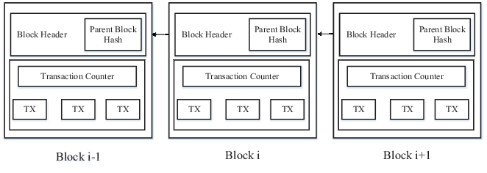

Fig. 1: An example of blockchain which consists of a contin-uous sequence of blocks.

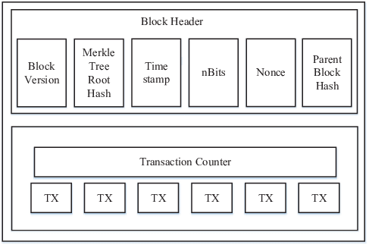

Fig. 2: Block structure

Blockchain is a sequence of blocks, which holds a complete list of transaction records like conventional public ledger . Figure 1 illustrates an example of a blockchain. With a previous block hash contained in the block header, a block has only one parent block. It is worth noting that uncle blocks (children of the block’s ancestors) hashes would also be stored in ethereum blockchain . The ﬁrst block of a blockchain is called genesis block which has no parent block.
We then explain the internals of blockchain in details.

A. Block:
A block consists of the block header and the block body as shown in Figure 2. In particular, the block header includes:
(i) Block version: indicates which set of block validation rules to follow.
(ii) Merkle tree root hash: the hash value of all the transactions in the block.
(iii) Timestamp: current time as seconds in universal time since January 1, 1970.
(iv) nBits: target threshold of a valid block hash.
(v) Nonce: an 4-byte ﬁeld, which usually starts with 0 and increases for every hash calculation (will be explained in details in Section III).
(vi) Parent block hash: a 256-bit hash value that point to the previous block.
The block body is composed of a transaction counter and transactions. The maximum number of transactions that a block can contain depends on the block size and the size of each transaction. Blockchain uses an asymmetric cryptography mechanism to validate the authentication of transactions . Digital signature based on asymmetric cryptography is used in an untrustworthy environment. We next brieﬂy illustrate digital signature.

B. Digital Signature:
Each user owns a pair of private key and public key. The private key that shall be kept in conﬁdentiality is used to sign the transactions. The digital signed transactions are broadcasted throughout the whole network. The typical digital signature is involved with two phases: signing phase and veriﬁcation phase. For instance, an user Alice wants to send another user Bob a message.
(1) In the signing phase, Alice encrypts her data with her private key and sends Bob the encrypted result and original data.
(2) In the veriﬁcation phase, Bob validates the value with Alice’s public key. In that way, Bob could easily check if the data has been tampered or not. The typical digital signature algorithm used in blockchains is the elliptic curve digital signature algorithm (ECDSA).

C. Key Characteristics of Blockchain:
In summary, blockchain has following key characteristics.
• Decentralization. In conventional centralized transaction systems, each transaction needs to be validated through the central trusted agency
(e.g., the central bank),
inevitably resulting to the cost and the performance bottlenecks at the central servers. Consensus algorithms in blockchain are used to maintain data consistency in distributed network.

Property | Public blockchain | Consortium blockchain | Private blockchain
Consensus determination | All miners | Selected set of nodes | One organization
Read permission | Public | Could be public or restricted | Could be public or restricted
Immutability | Nearly impossible to tamper | Could be tampered | Could be tampered
Efficiency | Low | High | High
Centralized | No | Partial | Yes
Consensus process | Permission less | Permissioned | Permissioned

TABLE I: Comparisons among public blockchain, consortium blockchain
private blockchain

• Persistency: Transactions can be validated quickly and invalid transactions would not be admitted by honest miners. It is nearly impossible to delete or rollback transactions once they are included in the blockchain. Blocks that contain invalid transactions could be discovered immediately.

• Anonymity: Each user can interact with the blockchain with a generated address, which does not reveal the real identity of the user. Note that blockchain cannot guarantee the perfect privacy preservation due to the intrinsic constraint

• Auditability. Bitcoin blockchain stores data about user balances based on the Unspent Transaction Output (UTX-O) model [2]: Any transaction has to refer to some previ-ous unspent transactions. Once the current transaction is recorded into the blockchain, the state of those referred unspent transactions switch from unspent to spent. So transactions could be easily verified and tracked.

D. Taxonomy of blockchain systems:

Current blockchain systems are categorized roughly into three types:
public blockchain, private block chain and con-sortium blockchain .
In public blockchain, all records are visible to the public and everyone could take part in the con-sensus process. Differently, only a group of pre-selected nodes would participate in the consensus process of a consortium blockchain.
As for private blockchain, only those nodes that come from one specific organization would be allowed to join the consensus process.A private blockchain is regarded as a centralized network since it is fully controlled by one organization.
The consortium blockchain constructed by several organizations is partially decentralized since only a small portion of nodes would be selected to determine the consensus. The comparison among the three types of blockchains is listed in Table I.

• Consensus determination:
In public blockchain, each n-ode could take part in the consensus process. And only a selected set of nodes are responsible for validating the block in consortium blockchain. As for private chain, it is fully controlled by one organization and the organization could determine the final consensus.

• Read permission. Transactions in a public blockchain are visible to the public while it depends when it comes to a private blockchain or a consortium blockchain.

• Efficiency. It takes plenty of time to propagate transactions and blocks as there are a large number of nodes on public blockchain network. As a result, transaction throughput is limited and the latency is high. With few validators, consortium blockchain and private blockchain could be more efficient.

• Centralized. The main difference among the three types of blockchains is that public blockchain is decentralized, consortium blockchain is partially centralized and private blockchain is fully centralized as it is controlled by a single group.

• Consensus process. Everyone in the world could join the consensus process of the public blockchain. Different from public blockchain, both consortium blockchain and private blockchain are permissioned.

Since public blockchain is open to the world, it can at-tract many users and communities are active. Many public blockchains emerge day by day. As for consortium blockchain, it could be applied into many business applications.
Currently Hyperledger is developing business consortium blockchain frameworks. Ethereum also has provided tools for building consortium blockchains .

IV. WORKING OF BLOCKCHAINS:

We will illustrate the working of Bitcoin transactions pri-marily in order to elucidate the working of Blockchain mech-anism. Bitcoin uses some sort of proof under Cryptographic primitives rather than entirely trusting on the third party. Hence, the concept of “digital signature was introduced”. The sender sends using his private key and the receiver receives using his public key and the person needs to know the private key and the digital signature, if he wishes to spend the money. The peer nodes present in the Bitcoin network is completely aware of the transactions being taking place. The transactions must be “endorsed” and “validated” in order to be reflected in a public ledger. Firstly, the validator must know that the sender has the right to spend it. Secondly, the validators must be aware that the sender has enough money in his account to make a “legit” transaction. The transactions in a Bitcoin network are not ordered. So, there is a chance of double spending and it could be removed by the introduction of Blockchain Technology. In Blockchain, the transactions are ordered in form of blocks in a linear chain, which are linked to each other.

Every block contains the hash of the block prior to it. We have introduced a concept called “Proof of Work”. In this, the task of the node is to find the random string or nonce. This random string has to be hashed with the transactions and the hashes of the previous blocks and then, it produces a hash with certain number of leading zeroes.

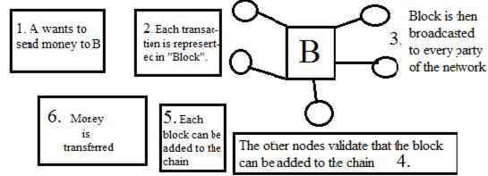

Fig. D.1 Workflow of the Blockchain Mechanism

V. BLOCKCHAIN APPLICATIONS:

As noted previously, the Blockchain is not a Bitcoin but a form of database stored in a decentralized system. The Blockchain can therefore be adapted for use in a variety of areas.
The following are just some of the Blockchain applications active today. A Financial Applications Bitcoin.The Bitcoin or digital currency was first introduced by an anonymous person or group under the alias Satoshi Nakamoto in 2008 . Bitcoin uses a Blockchain public ledger to make transactions across a peer to peer network. Examples of active Bitcoins are Bitbond, BitnPlay, BTC Jam, Codius and DeBuNe. The Ripple is a currency exchange, remittance and realtime gross settlement system (RTGS) that uses ripple protocol across a peer-to-peer network, a decentralized exchange that focuses on the banking market.
Other wellknown currency exchange and remittance systems are Coinbase, BitPesa, Billion, Stellar, Kraken and CryptoSigma. B. Non finanancial Applications
Ethereum. A Next-Generation Smart Contract and Decentralized Application Platform was created by a cryptocurrency researcher and programmer named Vitalik Buterin . It uses a Blockchain-based distributed computing platform with Turing complete scripting language that enables the processing of smart-contracts on the Blockchain. Hyperledger The Hyperledger is a Linux foundation project that develops Blockchain technologies for business, supporting only registered members. Hyperledger is an open source collaborative effort created to advance cross-industry Blockchain technologies. This is a global collaboration, hosted by The Linux Foundation, which includes leaders in finance, banking, the Internet of Things, supply chains, manufacturing and technology.
There are also many other non-financial applications using Blockchain technologies such as Election Voting (Follow My Vote), Smart Contracts (Otonomos, Mirror, Symbiont), and Blockchain in IoT (e-Plug, Filament).

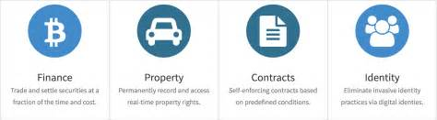

VI. BLOCKCHAIN RESEARCH IN THE MODERN WORLD

Blockchain is the newest topic in the domain of Computer Science and Security, as far as research is concerned. Many pioneer work has been done to improve the effiecieny of Blockchain . According to the research done by Zhao et al.
(2016), we have found that there has been an large scale increase
in the number of research papers on Blockchains. Blockchains has been considered as vulnerable to many of the attacks. Most of them have been unique and it could resist till now. chain.com is a startup backed by NASDAQ, which built a platform for equity markets on top of Blockchain. This is one of remarkable examples to show its excellence.
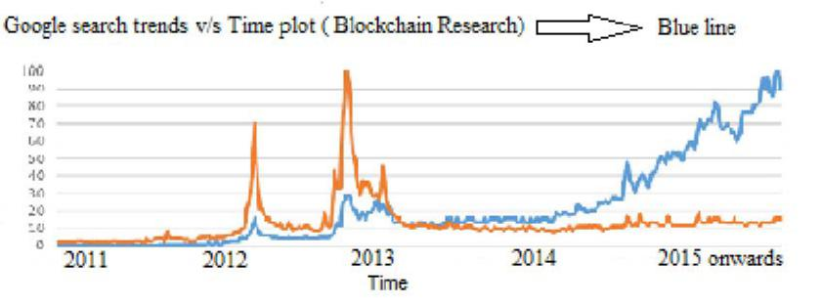

Fig. VI.1 Increase in the research of Blockchains

VII.CONCLUSION

Blockchain is still prevailing at its early stage of its research and development. Pioneer researchers in the domain of secu-rity and Cryptography have come forward to take it further to newer highs.
It is going to a great help for the Financial and Non Financial sectors. It will pay heed to the issues of reliability, security and shared knowledge at the same time. It has been one of the most attractive technologies since its inception.
This paper could conclude that there are numerous opportunities of research in this area and there is an urgent need to explore and seek for betterment just by minimizing the flaws and by enhancing its efficiencies.

REFERENCES:

- Ehsani and Farzam, “Blockchain in Finance: From Buzzword to Watch-word,” CoinDesk (News), 22 December, 2016.
- Linux Foundation unites the Industry leaders to advance Blockchain Technology, 2016.
- Open Source Blockchain Effort for the Enterprise Elects Leadership Positions and Gains New Investments, 2016.
- Zhao et al., “Financial Innovation,” 2-28, 2016.
- http://www.officialblockchain.site.com.
- http://www.learnblockchain.com
- Learn real time case studies of BlockChain Technology.---Amity University.
- http://www.revfine.com

